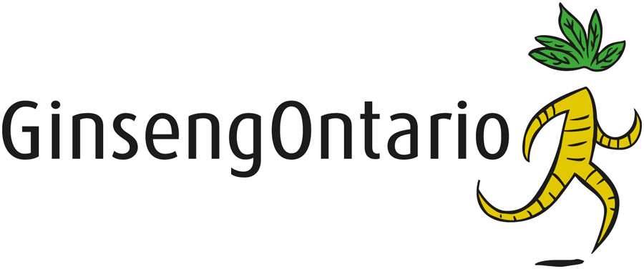

品質及原產地保證

Your assurance of quality
and origin

安省西洋參種植者協會（Ontario Ginseng Growers Association簡稱OGGA）是一個由安省監管並代表所有安省商品人參生產者的農業協會。協會的目標是進一步改進優質西洋參的生產方法，不斷促進西洋參這種有益健康產品的臨床研究，使安省成為世界上最大的優質西洋參生產地。
GinsengOntario （安省西洋參）標誌和“Running Root”（跑動的根）認可印章完全歸OGGA所有，經特許後才能使用。
產品包裝上印有經認可的“Running Root” 印章，表明其中的西洋參是在安省當地土壤中培育出來的100%正宗北美人參（西洋參/花旗參）。

The Ontario Ginseng Growers Association (OGGA) is a provincially regulated agricultural association representing Ontario’s commercial ginseng producers. The Association’s goals are to further the quality production methods of ginseng, support continuing clinical research into ginseng as a contributor to health wellness and advance Ontario as the largest high quality North American Ginseng producer region in the world.
The Ginseng Ontario logo and the “Running Root” Certification Mark are wholly owned by the OGGA and used under license.
Consumer products bearing the authorized “Running Root” Seal indicates the ginseng content is 100% North American Ginseng (panax quinquefolius) grown in their native Ontario soils.

CGC Ginseng Inc.
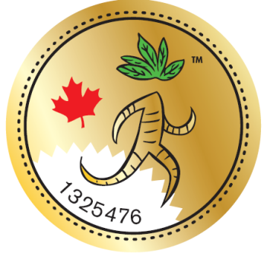

Authorized by: Rebecca Coates
Executive Director, OGGA

No. 19081 - 19580

“Running Root” （跑動的根）印章

More information on the OGGA and North American Ginseng is available at www.ginsengontario.com
若需要更多有關安省西洋參種植者協會（OGGA）及西洋參的資訊，可訪問www.ginsengontario.com

本證明是安省西洋參種植者協會（OGGA）的財產

This certificate is the property of the Ontario Ginseng Growers Association

VALID: July 2017 – July 2018

